Article 7 — The Optimization Problem
Michal Doroszewski
You’re driving with a GPS that seems unusually confident. It announces your route with the calm authority of someone who has never once been wrong. You follow its instructions. You turn left. You merge right. You glide through a roundabout that looks like it was designed by someone who hates drivers. Everything seems fine.
Then the recalculations begin.
At first, it’s subtle — a gentle “Recalculating…” followed by a minor adjustment. Then it happens again. And again. Soon the GPS is recalculating every thirty seconds, sending you down side streets, U-turns, and “shortcuts” that add twenty minutes to the trip. You pass the same gas station three times. You begin to suspect the GPS is improvising.
You check your signal. Full bars. You check the map. It looks normal. You check the road. Also normal. The only thing that isn’t normal is the GPS’s sudden belief that you should take a left into a cornfield.
You haven’t changed. The road hasn’t changed. The destination hasn’t changed. The only thing that changed was the system’s ability to see the path clearly.
That is the Optimization Problem. Not the “bad algorithm” kind — the architectural kind. The kind that appears when cloud systems try to optimize performance, routing, identity, or media flow using signals that are missing, delayed, or distorted. The kind that makes the system recalculate endlessly because it cannot trust the information it has.
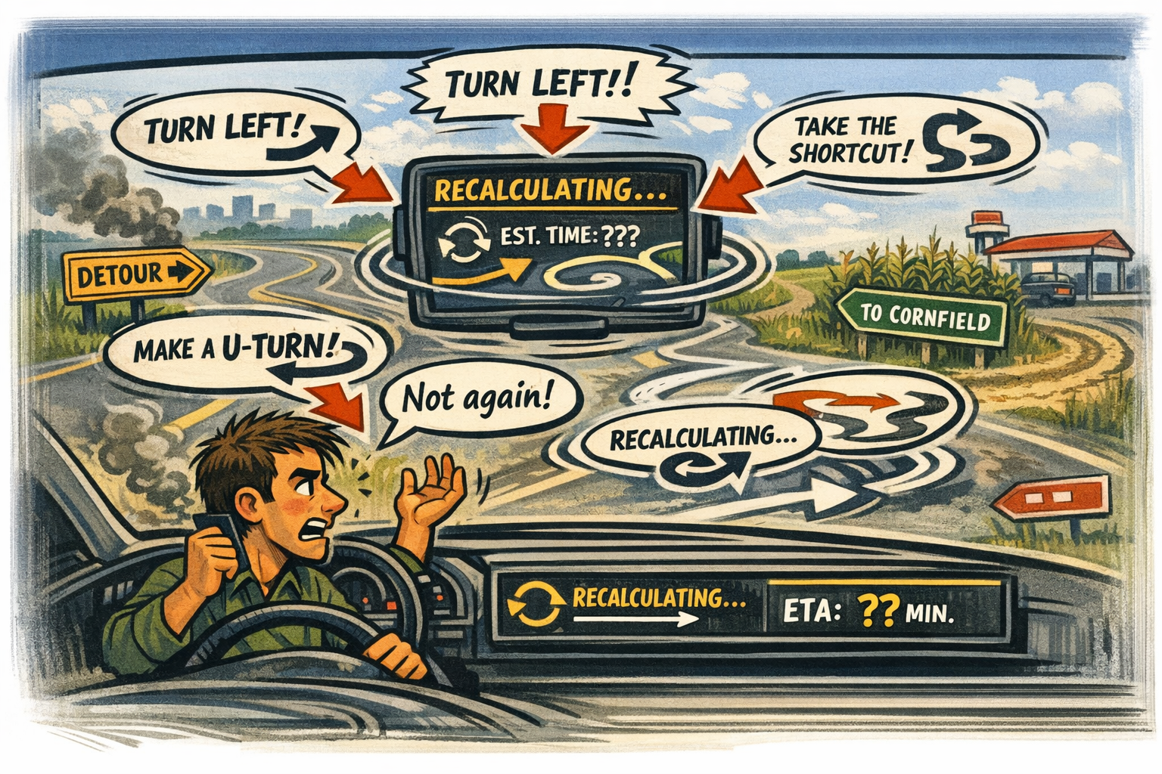
How Optimization Became a Continuous Process
Cloud systems don’t optimize once. They optimize constantly. Every session, every token, every media stream, every region selection — all of it is continuously evaluated and adjusted. Optimization is not a feature. It is the operating model.
In Commercial environments, this works beautifully. The cloud sees the user’s location, timing, risk, device trust, and session continuity. It adjusts intelligently. It adapts smoothly. It behaves like a GPS with perfect satellite visibility.
In GCC-Moderate, the satellites are behind a boundary.
Why Optimization Fails Without Telemetry
Optimization depends on telemetry. When telemetry is missing, optimization becomes guesswork.
The system tries to select the best region, but the boundary hides the user’s true location. It tries to refresh tokens, but inspection layers delay the timing. It tries to maintain session continuity, but WAN optimizers reshape packets in ways that look like instability. It tries to evaluate risk, but risk scoring never arrives. It tries to route media intelligently, but the architecture hides the path.
The cloud isn’t making bad decisions. It’s making decisions with partial information.
A GPS with a clear view of the sky gives you the fastest route.
A GPS with one satellite and a dream gives you a tour of the county.
Why Headquarters and Field Offices Experience Different Optimization Loops
Headquarters sits close to cloud egress, identity controllers, and stable paths. Optimization works as intended. The system sees the signals it needs. It recalculates rarely, and when it does, it’s correct.
Field offices sit behind WAN optimizers, MPLS circuits, regional hubs, and inspection layers. Optimization becomes a loop. The system recalculates constantly because the signals it receives contradict each other. Region selection drifts. Token refreshes arrive late. Session continuity looks unstable. Media flows take detours that make no sense.
Headquarters sees a system that behaves.
Field offices see a system that second-guesses itself every thirty seconds.
Both are describing the same architecture.
They are simply standing in different places.
Why Optimization Creates Conflicting Truths
Optimization is supposed to converge. In GCC-Moderate, it diverges.
Network teams see stable paths.
Cloud teams see unstable sessions.
Security teams see inconsistent risk.
Help desks see unpredictable user experience.
Leadership sees conflicting reports that are all true but incomplete.
Each team is looking at a different recalculation.
Each recalculation is based on different signals.
Each signal is distorted by the boundary.
The system isn’t confused.
It’s reacting to the truth it can see — even if that truth is wrong.
Why Modernization Efforts Stall When Optimization Loops Multiply
Modernization depends on predictable behavior. Optimization loops break predictability.
A fix that stabilizes one region destabilizes another.
A change that improves headquarters breaks field offices.
A policy that works in testing collapses in production.
A routing improvement that looks promising in logs behaves differently in real life.
The architecture is not resisting modernization.
It is optimizing based on incomplete information.
You cannot modernize a system that recalculates every thirty seconds.
You cannot stabilize a system that cannot see the road.
You cannot optimize a system that cannot trust its own signals.
The Root of the Optimization Problem
The optimization problem is not caused by misconfiguration, lack of skill, or insufficient tuning. It is caused by an architecture that predates continuous optimization.
The boundary hides the signals optimization depends on.
The WAN distorts the timing optimization requires.
The region model predates the workloads it now supports.
The telemetry pipelines are restricted by design.
The system is not failing.
It is optimizing inside a blindfold.
The Only Way Forward
Optimization must be allowed to see the truth.
The boundary must allow the signals cloud systems use to make decisions.
Telemetry must be restored.
Region awareness must be accurate.
Session continuity must be visible.
Risk scoring must be available.
Media flow must reflect reality.
Only then can optimization converge.
Only then can the system stop recalculating.
Only then can modernization move forward without guesswork.
Only then can the architecture behave the way it was designed to behave.
About the Author
Michal Doroszewski
Michal Doroszewski is a technology strategist focused on cloud architecture, identity platforms, and federal modernization. He writes about the structural and architectural forces that shape government IT, translating complex technical constraints into clear, accessible narratives for leaders and practitioners.

